

# **Module: GUI Design and Database Connection**

# **Module Code: COMP4604**

# **Course Code: TU819/4**

# **Course Group: Group A/B**

# **Student Names: Jason Leonard & Brian Twene**

# **Student IDs: C19500766, C19344543**

# **Submission Date: 04/12/2022**

# **Topic: Vehicle Dealership/Rental System**

**Module: GUI Design and Database Connection** 1

**Module Code: COMP4604** 1

**Course Code: TU819/4** 1

**Course Group: Group A/B** 1

**Student Names: Jason Leonard & Brian Twene** 1

**Student IDs: C19500766, C19344543** 1

**Submission Date: 04/12/2022** 1

**Topic: Vehicle Dealership/Rental System** 1

**Introduction** 3

**User Manual (Customer)** 3

**Register Page (Customer)** 3

**Login Page (Customer)** 4

**Reset Password Page (Customer)** 5

**Main Menu Page (Customer)** 6

**Home Page (Customer)** 7

**Rentals Page (Customer)** 8

**Purchase Page** 9

**Rental / Purchase Checkout Page** 10

**Current Rentals (Customer)** 11

**Account Details (Customer)** 12

**History Rental & Purchase (Customer)** 13

**User Manual (Admin)** 14

**Login Page (Admin)** 14

**Main Menu (Admin)** 15

**Manage Customers Page (Admin)** 16

**Manage Vehicles Page (Admin)** 17

# **Introduction**

This user manual document is based on a software solution for a vehicle dealership which allows a user to both purchase vehicles, rent vehicles and return vehicles when they’re finished using them. Additionally, the program also allows an admin to alter a user’s and vehicles table which is located within a Microsoft Access database, and allows the admin to add, edit, and remove information from their respective tables. Our application also features stock and inventory control and allows management to print a list of users and a list of our stock and inventory. Lastly, an admin is also able to use this program to check overdue accounts for people who have not returned their rented vehicle.

# **User Manual (Customer)**

## **Register Page (Customer)**

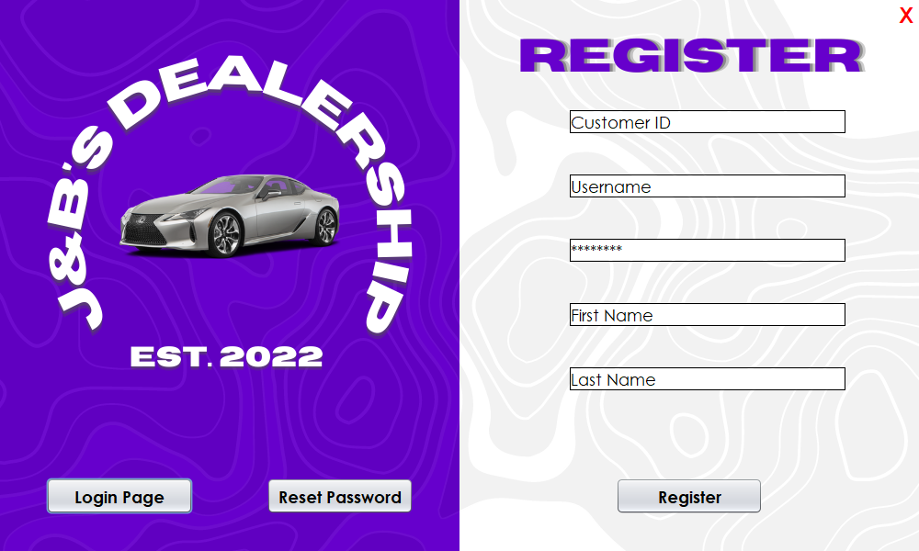

**Step 1:** Enter a random number for your Customer ID

**Step 2:** Enter your desired username (this username can only be changed by an Admin).

**Step 3:** Enter the password you’d like to use (this password can be changed in the future via the Reset Password page).

**Step 4:** Enter your First Name.

**Step 5:** Enter your Last Name.

**Step 6:** Click Register.

**Step Final:** You’ll now be redirected to the Login Page.

**Login Page:** Click the Login Page button to go to the Login Page.

**Reset Password:** Click the Reset Password button to go to the Reset Password Page.

**X:** Click the X icon in the top right to exit the program.

## **Login Page (Customer)**

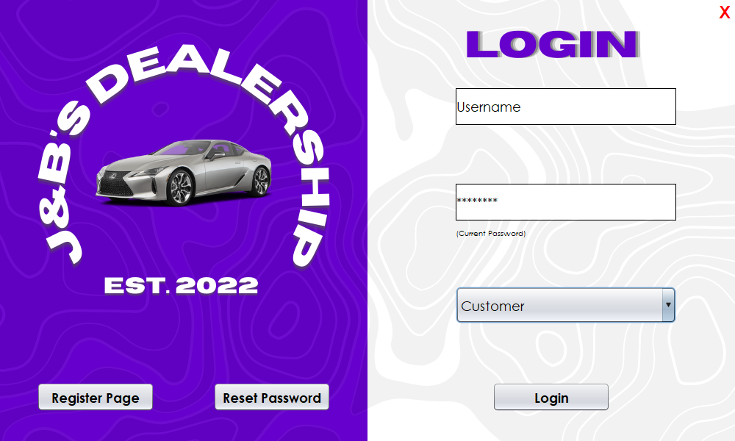

**Step 1:** Enter the username you registered with above in the Username text field box above.

**Step 2:** Enter the password you used to register with that username above.

**Step 3:** Click the drop-down menu and select Customer.

**Step 4:** Click Login.

**Step Final:** You’ll now be redirected to the Main Menu Page for the Customer.

**Register Page:** Click the Register Page button to go to the Register Page.

**Reset Password:** Click the Reset Password button to go to the Reset Password Page.

**X:** Click the X icon in the top right to exit the program.

## **Reset Password Page (Customer)**

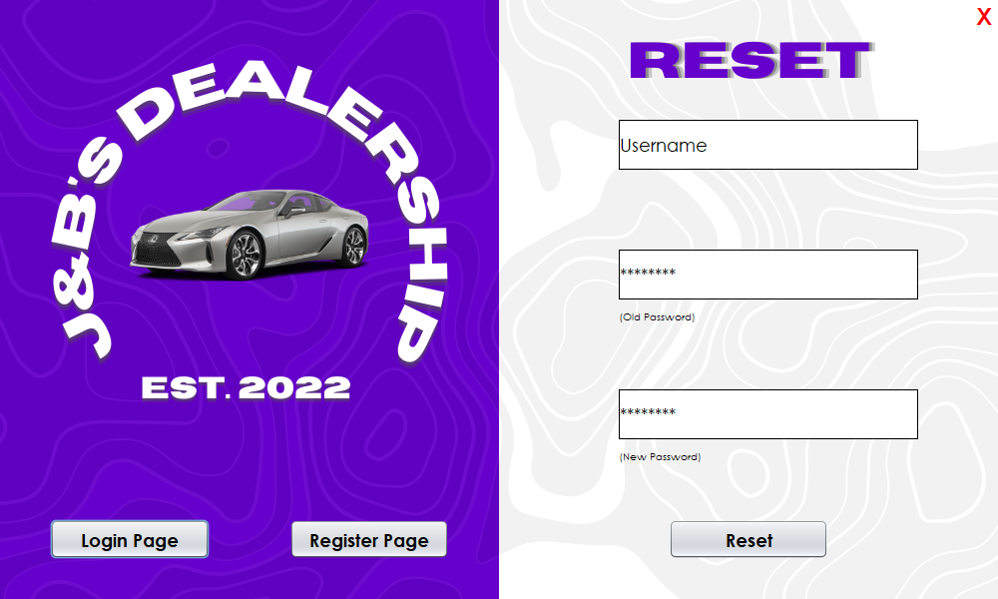

**Step 1:** Enter the username you registered with.

**Step 2:** Enter your old password.

**Step 3:** Enter your new password.

**Step 4:** Click Reset.

**Step Final:** You’ll now be redirected to the Login Page.

**Login Page:** Click the Login Page button to go to the Login Page.

**Register Page:** Click the Register Page button to go to the Register Page.

**X:** Click the X icon in the top right to exit the program.

## **Main Menu Page (Customer)**

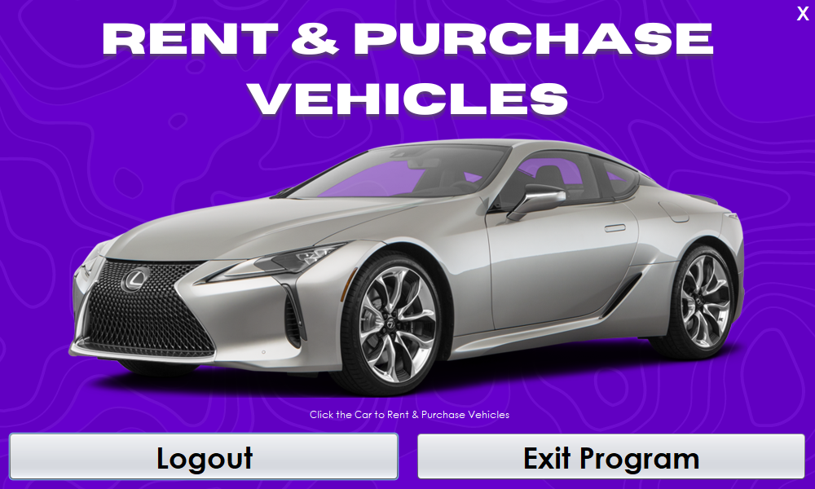

**Rent & Purchase Vehicles:** Click on the Car to go to the Rent & Purchase Vehicles page.

**Logout:** Click on the Logout button to go back to the Login page.

**Exit Program:** Click on the Exit button to exit out of the program in its entirety.

**X:** Click the X icon in the top right to exit the program.

## **Home Page (Customer)**

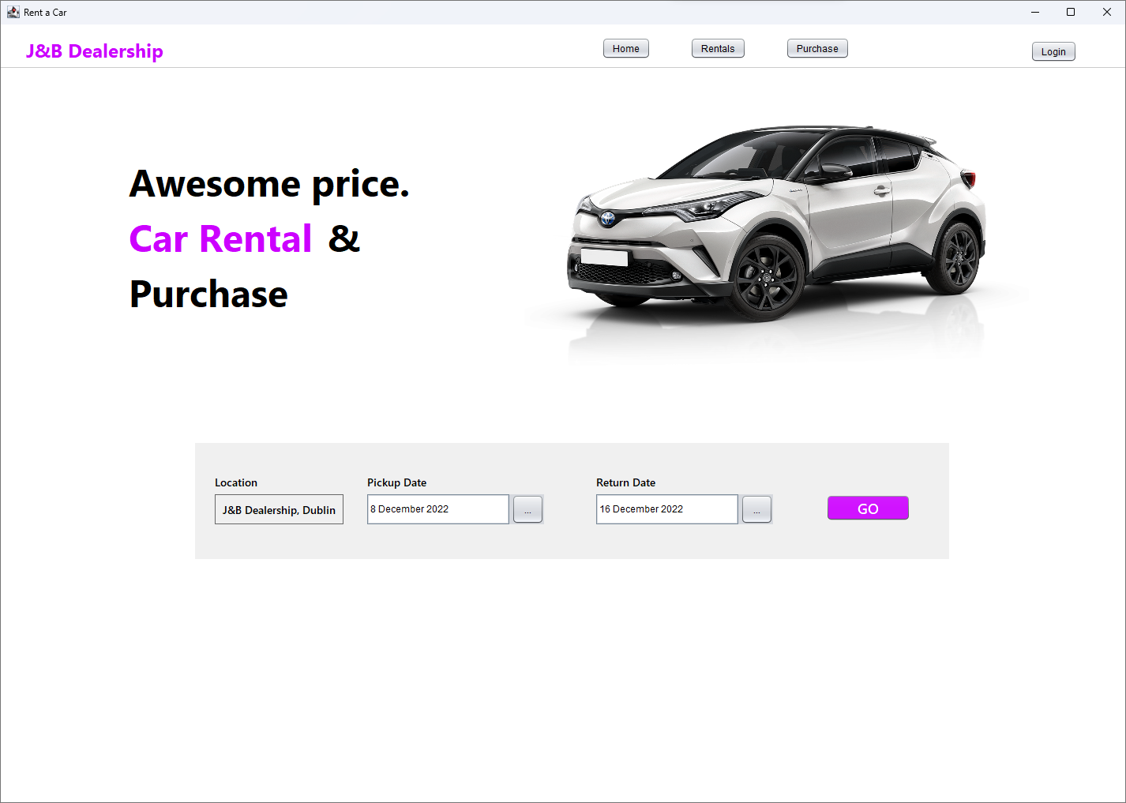

**Step 1:** Enter a pickup and return date.

**Step 2:** Default pickup location is set already.

**Step 3:** Hit the “Go” button to go to the Rentals page.

**Home:** You’ll now be redirected to the Home Page.

**Rentals:** Click the Rentals Page button to go to the Rentals Page.

**Purchases:** Click the Purchases button to go to the Purchases Page.

**Login:** Click this button to be redirected to the login page.

## **Rentals Page (Customer)**

**Step 1:** Use the filter on the left to narrow down options.

**Step 2:** Use the reset button to restore the options.

**Step 3:** Click on the Rent button to go to the checkout page.

**Filter by Vehicle Type:** Filter by type that suits your needs.

**Filter by Class:** Select from the budget friendly budget class up to luxury.

**Filter by Price:** Filter by price.

## **Purchase Page**

**Step 1:** Use the filter on the left to narrow down options.

**Step 2:** Use the reset button to restore the options.

**Step 3:** Click on the Buy button to go to the checkout page.

**Filter by Vehicle Type:** Filter by type that suits your needs.

**Filter by Class:** Select from the budget friendly budget class up to luxury.

**Filter by Price:** Filter by price.

## **Rental / Purchase Checkout Page**

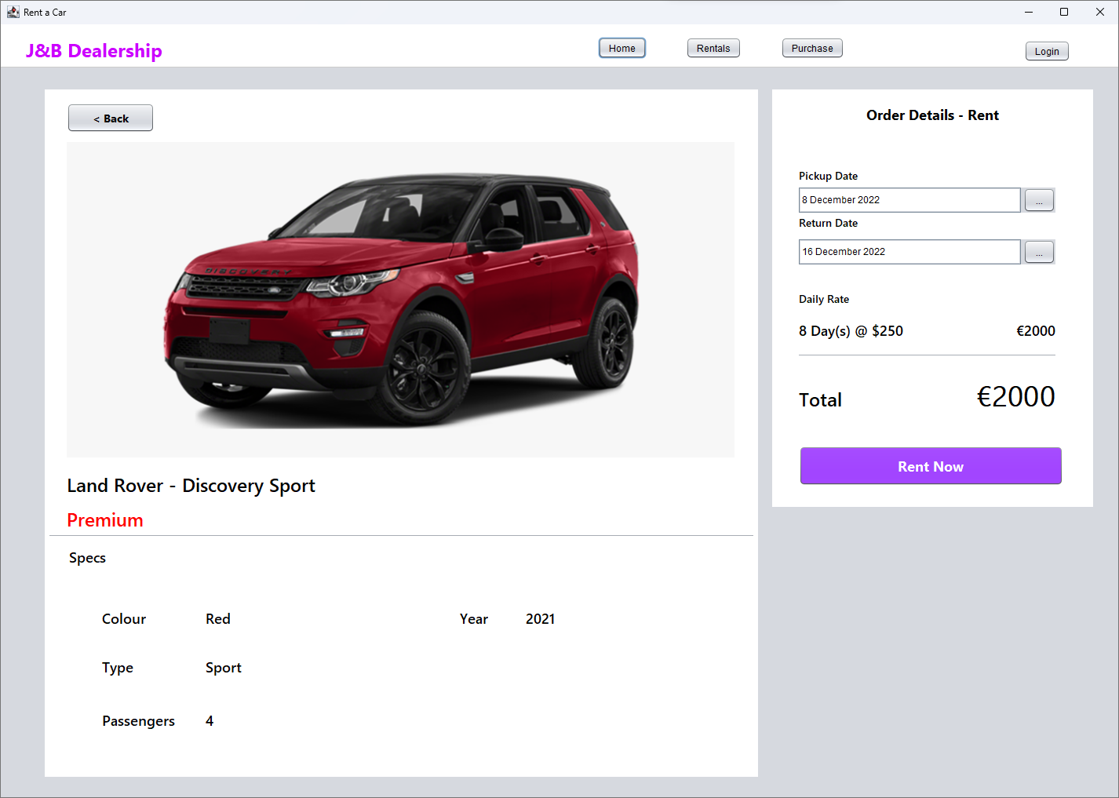

**Step 1:** Verify the vehicle you want to rent/purchase is this one.

**Step 2:** If renting you’ll have the option to select the pickup and return date if you have changed your mind from the home page.

**Step 3:** Click on the “Rent Now” button to rent the vehicle or purchase if buying.

## **Current Rentals (Customer)**

**Select Location:** Choose from various locations to return your vehicle to.

**Return:** Confirms the location you want to return to.

## **Account Details (Customer)**

**Change Password:** Redirects you to a reset password page where you can change your password based on the account you’re logged in to.

## **History Rental & Purchase (Customer)**

Above shows the history for both rentals and purchases, when you rent or purchase a car, the history of either will show up in the tables above.

# **User Manual (Admin)**

## **Login Page (Admin)**

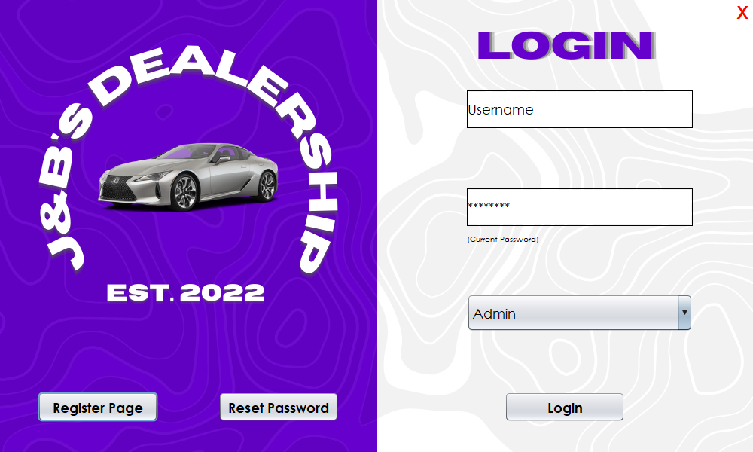

**Step 1:** Enter the username you registered with above in the Username text field box above.

**Step 2:** Enter the password you used to register with that username above.

**Step 3:** Click the drop-down menu and select Admin.

**Step 4:** Click Login.

**Step Final:** You’ll now be redirected to the Main Menu Page for the Admin.

**Register Page:** Click the Register Page button to go to the Register Page.

**Reset Password:** Click the Reset Password button to go to the Reset Password Page.

**X:** Click the X icon in the top right to exit the program.

## **Main Menu (Admin)**

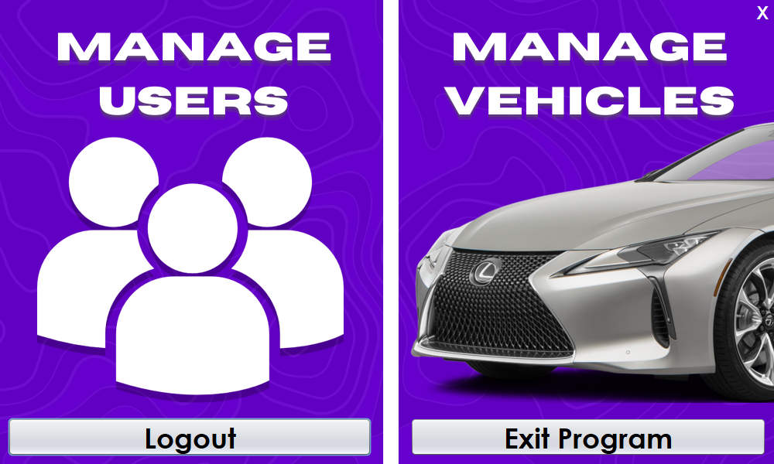

**Manage Users:** Click on the White Users Icon to go to the Manage Users page.

**Manage Vehicles:** Click on the Car to go to the Manage Vehicles page.

**Logout:** Click on the Logout button to go back to the Login page.

**Exit Program:** Click on the Exit button to exit out of the program in its entirety.

**X:** Click the X icon in the top right to exit the program.

## **Manage Customers Page (Admin)**

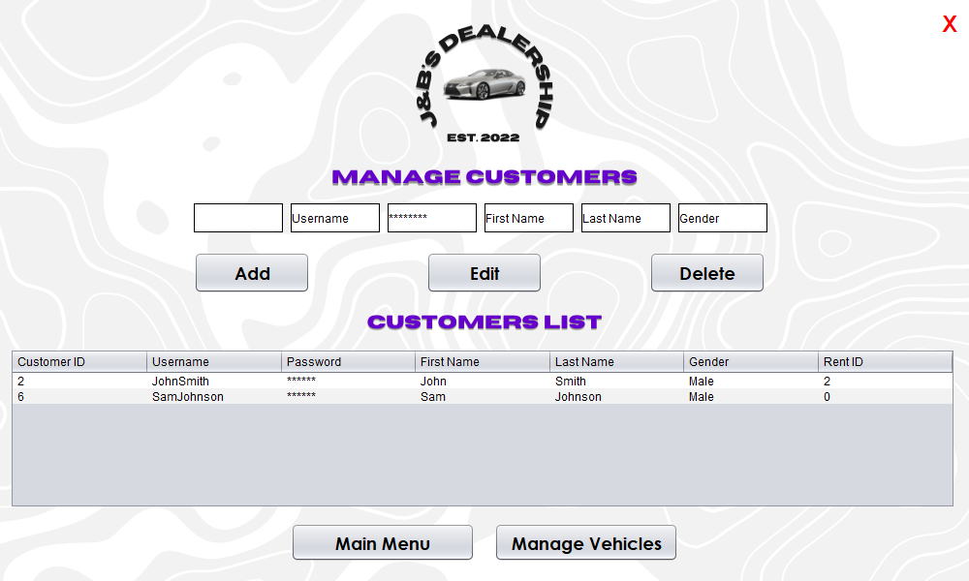

**Step 1:** Input Customer ID.

**Step 2:** Input Customer Username.

**Step 3:** Input Customer Password.

**Step 4:** Input Customer First Name.

**Step 5:** Input Customer Last Name.

**Step 6:** Input Customer Gender.

**Add:** Inserts information into the database.

**Edit:** Updates information that is already present in the database.

**Delete:** Deletes information from the database.

**Customers List:** Displays a list of all the customers currently within the database.

**Main Menu:** Goes to the Main Menu Page for the Admin.

**Manage Vehicles:** Goes to the Manage Vehicles Page.

## **Manage Vehicles Page (Admin)**

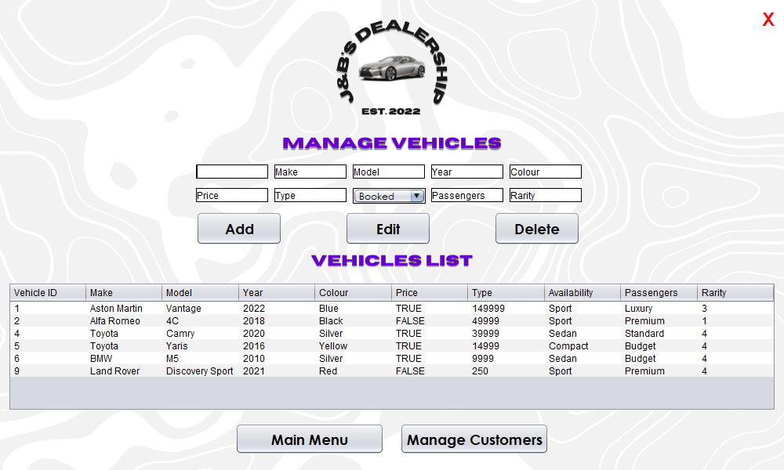

**Step 1:** Input Vehicle ID.

**Step 2:** Input Vehicle Make.

**Step 3:** Input Vehicle Model.

**Step 4:** Input Vehicle Year.

**Step 5:** Input Vehicle Colour.

**Step 6:** Input Vehicle Price.

**Step 7:** Input Vehicle Type.

**Step 8:** Input Vehicle Availability.

**Step 9:** Input Vehicle Passengers.

**Step 10:** Input Vehicle Rarity.

**Add:** Inserts information into the database.

**Edit:** Updates information that is already present in the database.

**Delete:** Deletes information from the database.

**Vehicles List:** Displays a list of all the vehicles currently within the database.

**Main Menu:** Goes to the Main Menu Page for the Admin.

**Manage Customers:** Goes to the Manage Customers Page.